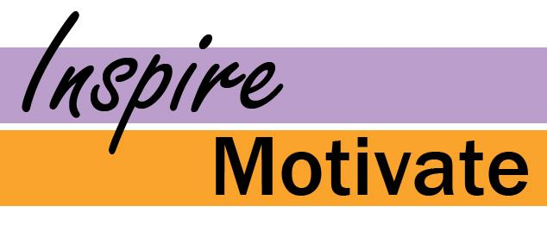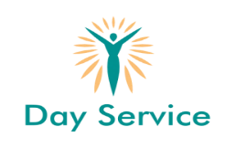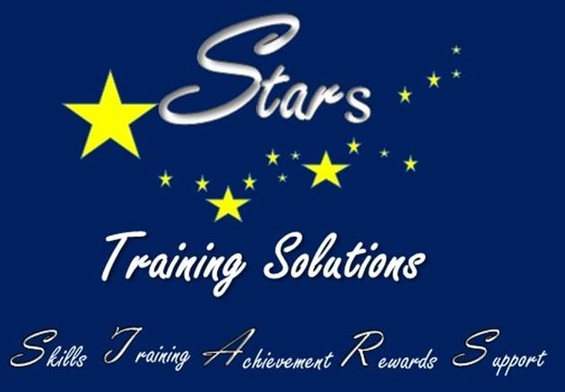

We work with service users who have a variety of complex needs including Autism, Asperger’s and Downs Syndrome.

Activities which stimulate, challenge, develop and accelerate learning.

Make friends in a vibrant setting.

Make your day meaningful and interesting.

We offer a wide range of

activities to choose from

including:

* Arts and Craft
* Splash Forward
* Sensory Development
* Health and Fitness
* Themed Days
* Community Activities





Stars Day Service specialises in providing a service for young people and adults with learning difficulties

